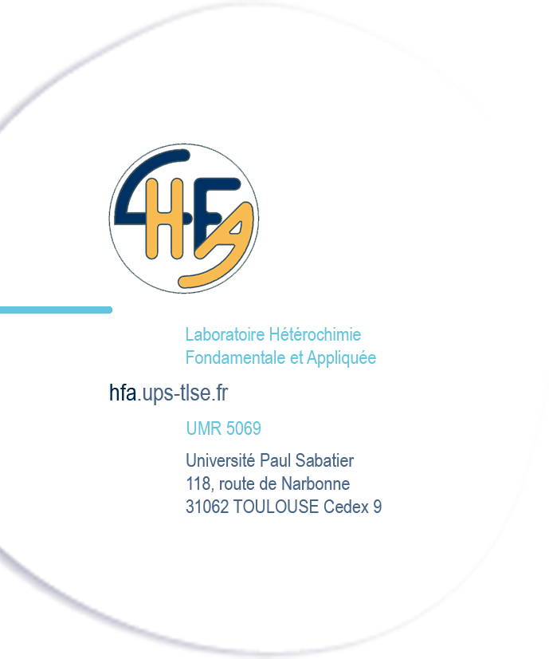
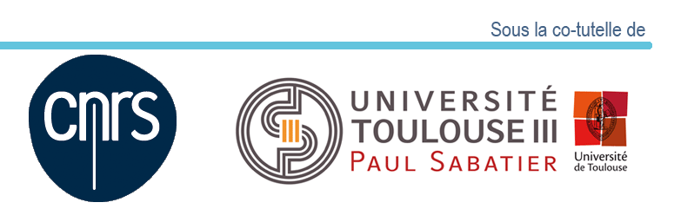
Dr. Didier Bourissou, Dr. Ghenwa Bouhadir
Bifunctional Ligands and Biodegradable Polymers, LBPB
: UPS, Bât 2R1, 2ème étage
e-mail : lbpb@chimie.ups-tlse.fr
phone: 33(0)5 6155 6123 – Fax : 33(0)5 6155 8204

Post-doctoral / Research Engineer position (1 year)

Heteroelement-based molecules for pyrotechnic smoke applications

In the frame of a collaboration with an industrial partner of the defense sector, our laboratory recently developed a new project focusing on energetic molecules for use in pyrotechnic compositions for the production of masking fumes. Although some products are widely used in this field, the historical example being red phosphorus, the search for new molecules that are more respectful of people and the environment is currently a major challenge. To address this need, we have designed new families of compounds based on main-group elements (P, B, Si…) and developed a synthetic route that complies with the technical specifications. The first tests of the corresponding pyrotechnic compositions allowed to select a few target molecules meeting the required properties.

Based on these first very promising results, it is our aim in this project to prepare new molecules to (i) expand the chemical variety of compounds initially tested and (ii) refine / adjust the properties of the target molecules in order to maintain their performance while minimizing their impact on the environment (iii) establish a structure / property relationship. To this end, particular attention will be devoted to the modulation of the electronic and steric properties of the target molecules.

The performance of the new compounds will be tested by the industrial partner which has strong expertise in the field. The most effective compounds will be assessed for toxicity.

This project is based on the know-how of our laboratory in heteroatom-containing molecules. The synthetic work takes into account the requirements of modern chemistry.

The candidate should have solid expertise in the synthesis, purification and characterization of organic derivatives. Experience in main-group chemistry is desirable but not mandatory. Good communication and writing skills, including in English are required.

The start of the position is scheduled for May-June 2021. Please send a cover letter, a detailed CV as well as the reference details (e-mail and / or phone) to the following e-mail address: lbpb@chimie.ups-tlse.fr specifying in the title "FUMIR”.

